SAVEETHA INSTITUTE OF MEDICAL AND TECHNICAL SCIENCES
SIMATS ENGINEERING
SUB CODE & NAME: CSA17- ARTIFICIAL INTELLIGENCE
LIST OF EXPERIMENTS

1.Write the python program to solve 8-Puzzle problem

Aim
To develop a Python program to solve the 8-Puzzle Problem using the A* Search Algorithm by accepting the initial state and goal state from the user and finding the shortest sequence of moves.
Algorithm
- Start the program.
- Read the initial state from the user.
- Read the goal state from the user.
- Define the Manhattan Distance heuristic function.
- Insert the initial state into the priority queue.
- Repeat until the priority queue becomes empty:
  - Remove the state with the lowest heuristic cost.
  - If the current state is the goal state, display the solution path and stop.
  - Generate all valid neighboring states.
  - Calculate the heuristic value for each neighboring state.
  - Insert unvisited neighboring states into the priority queue.
- If no solution is found, display "No Solution Exists."
- Stop.
Program
import heapq
# Read puzzle state from user
def read_state(name):
print(f"\nEnter the {name} (3 rows, space-separated):")
state = []
for i in range(3):
row = list(map(int, input().split()))
state.append(tuple(row))
return tuple(state)
# Manhattan Distance Heuristic
def heuristic(state, goal):
distance = 0
goal_pos = {}
# Store goal positions
for i in range(3):
for j in range(3):
goal_pos[goal[i][j]] = (i, j)
for i in range(3):
for j in range(3):
value = state[i][j]
if value != 0:
x, y = goal_pos[value]
distance += abs(i - x) + abs(j - y)
return distance
# Find blank tile (0)
def find_blank(state):
for i in range(3):
for j in range(3):
if state[i][j] == 0:
return i, j
# Generate neighboring states
def get_neighbors(state):
neighbors = []
x, y = find_blank(state)
moves = [(-1,0), (1,0), (0,-1), (0,1)]
for dx, dy in moves:
nx, ny = x + dx, y + dy
if 0 <= nx < 3 and 0 <= ny < 3:
new_state = [list(row) for row in state]
new_state[x][y], new_state[nx][ny] = new_state[nx][ny], new_state[x][y]
neighbors.append(tuple(tuple(row) for row in new_state))
return neighbors

# Print puzzle state
def print_state(state):
for row in state:
print(*row)
print()
# A* Search Algorithm
def a_star(start, goal):
pq = []
heapq.heappush(pq, (heuristic(start, goal), 0, start, []))
visited = set()
while pq:
f, g, current, path = heapq.heappop(pq)
if current in visited:
continue
visited.add(current)
if current == goal:
return path + [current]
for neighbor in get_neighbors(current):
if neighbor not in visited:
heapq.heappush(
pq,
(
g + 1 + heuristic(neighbor, goal),
g + 1,
neighbor,
path + [current]
)
)
return None

# ---------------- Main Program ----------------
start = read_state("Initial State")
goal = read_state("Goal State")
solution = a_star(start, goal)
if solution:
print("\nSolution Found in", len(solution)-1, "moves.\n")
for i, state in enumerate(solution):
print("Step", i)
print_state(state)
else:
print("\nNo Solution Exists.")
Sample Input:
Enter the Initial State (3 rows, space-separated):
1 2 3
4 0 6
7 5 8

Enter the Goal State (3 rows, space-separated):
1 2 3
4 5 6
7 8 0
Sample output:
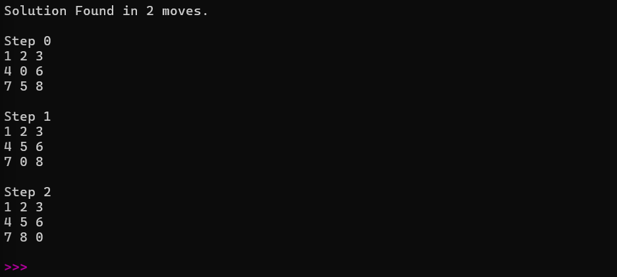

Result
The Python program was successfully implemented to solve the 8-Puzzle Problem using the A* Search Algorithm. The program accepts the initial state and goal state from the user, computes the optimal solution using the Manhattan Distance heuristic, and displays the shortest sequence of moves along with all intermediate puzzle states until the goal state is reached.

2. Write the python program to solve 8-Queen problem

Aim
To develop a Python program to solve the 8-Queen Problem using the Backtracking Algorithm by accepting the board size (N) from the user and placing N queens on an N × N chessboard such that no two queens attack each other.

Algorithm
- Start the program.
- Read the number of queens (N) from the user.
- Create an empty N × N chessboard.
- Begin placing queens column by column.
- For each row in the current column:
  - Check whether placing the queen is safe.
  - If safe, place the queen.
  - Recursively place queens in the next column.
  - If a solution is found, stop.
  - Otherwise, remove the queen (Backtrack).
- Repeat until all queens are placed.
- Display the chessboard if a solution exists; otherwise display "No Solution Exists."
- Stop.

Program
# Function to check whether a queen can be placed safely
def is_safe(board, row, col, n):

# Check left side of current row
for i in range(col):
if board[row][i] == 1:
return False

# Check upper-left diagonal
i = row
j = col
while i >= 0 and j >= 0:
if board[i][j] == 1:
return False
i -= 1
j -= 1

# Check lower-left diagonal
i = row
j = col
while i < n and j >= 0:
if board[i][j] == 1:
return False
i += 1
j -= 1

return True

# Backtracking function
def solve_nqueen(board, col, n):

if col >= n:
return True

for i in range(n):
if is_safe(board, i, col, n):

board[i][col] = 1

if solve_nqueen(board, col + 1, n):
return True

board[i][col] = 0

return False

# Main Program
n = int(input("Enter the number of Queens (N): "))

board = [[0 for i in range(n)] for j in range(n)]

if solve_nqueen(board, 0, n):

print("\nSolution Exists:\n")

for row in board:
for cell in row:
if cell == 1:
print("Q", end=" ")
else:
print(".", end=" ")
print()

else:
print("No Solution Exists.")

Input
Enter the number of Queens (N): 8

Output

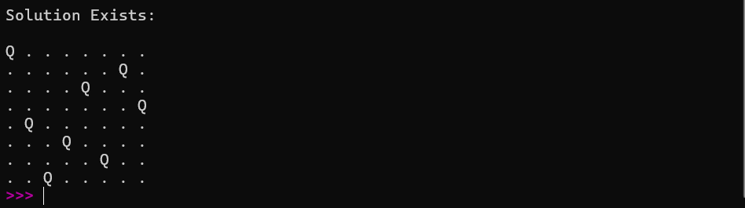
.

Result
The Python program was successfully implemented to solve the 8-Queen Problem using the Backtracking Algorithm. The program accepts the number of queens (N) from the user, places the queens on an N × N chessboard such that no two queens attack each other, and displays one valid solution if it exists. This demonstrates the effectiveness of the backtracking technique in solving constraint satisfaction problems.

3. Write the python program for Water Jug Problem

Aim
To develop a Python program to solve the Water Jug Problem using the Breadth-First Search (BFS) Algorithm by accepting the capacities of two jugs and the target amount from the user.

Algorithm
- Start the program.
- Read the capacities of Jug 1, Jug 2, and the target amount.
- Initialize the initial state as (0, 0).
- Insert the initial state into a queue.
- Repeat until the queue becomes empty:
  - Remove the front state.
  - If the target amount is reached, display the solution path and stop.
  - Generate all possible next states:
    - Fill Jug 1.
    - Fill Jug 2.
    - Empty Jug 1.
    - Empty Jug 2.
    - Pour water from Jug 1 to Jug 2.
    - Pour water from Jug 2 to Jug 1.
  - Add all valid and unvisited states to the queue.
- If no solution is found, display "No Solution Exists."
- Stop.

Program
from collections import deque

# Function to solve Water Jug Problem using BFS
def water_jug_bfs(jug1, jug2, target):
visited = set()
queue = deque()
# Initial state
queue.append((0, 0, []))
while queue:
x, y, path = queue.popleft()
if (x, y) in visited:
continue
visited.add((x, y))
path = path + [(x, y)]
# Goal condition
if x == target or y == target:
return path
# Possible operations
next_states = [
(jug1, y), # Fill Jug1
(x, jug2), # Fill Jug2
(0, y), # Empty Jug1
(x, 0), # Empty Jug2
]
# Pour Jug1 -> Jug2
transfer = min(x, jug2 - y)
next_states.append((x - transfer, y + transfer))
# Pour Jug2 -> Jug1
transfer = min(y, jug1 - x)
next_states.append((x + transfer, y - transfer))
for state in next_states:
if state not in visited:
queue.append((state[0], state[1], path))
return None

# Main Program
jug1 = int(input("Enter capacity of Jug 1: "))
jug2 = int(input("Enter capacity of Jug 2: "))
target = int(input("Enter target amount: "))
solution = water_jug_bfs(jug1, jug2, target)
if solution:
print("\nSolution Path:")
for step in solution:
print(step)
else:
print("\nNo Solution Exists.")

Input
Enter capacity of Jug 1: 4
Enter capacity of Jug 2: 3
Enter target amount: 2

Output
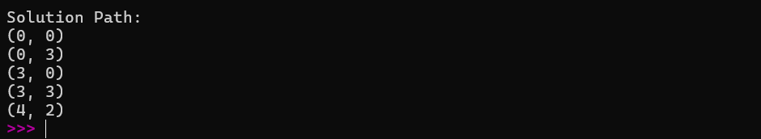

Result
The Python program was successfully implemented to solve the Water Jug Problem using the Breadth-First Search (BFS) Algorithm. The program accepts the capacities of the two jugs and the target amount from the user, finds a valid sequence of operations, and displays the intermediate states required to obtain the target amount of water. This demonstrates the use of BFS in solving state-space search problems in Artificial Intelligence.

4. Write the python program for Cript-Arithmetic problem

Aim
To develop a Python program to solve the Crypt-Arithmetic Problem by assigning unique digits to letters such that the given arithmetic equation is satisfied.

Algorithm
- Start the program.
- Read the first word, second word, and result word.
- Identify all unique letters.
- Check whether the number of unique letters is less than or equal to 10.
- Generate all possible digit assignments using permutations.
- Ignore assignments where any leading letter is assigned zero.
- Convert the words into numbers using the current assignment.
- Check whether:
  - First Number + Second Number = Result Number.
- If the equation is satisfied:
  - Display the letter-to-digit mapping.
  - Display the verified arithmetic expression.
  - Stop.
- If all assignments are checked and no solution is found, display "No Solution Exists."
- Stop.

Program
from itertools import permutations
# Input words
word1 = input("Enter First Word: ").upper()
word2 = input("Enter Second Word: ").upper()
result = input("Enter Result Word: ").upper()
# Get unique letters
letters = list(set(word1 + word2 + result))
# Check if more than 10 unique letters
if len(letters) > 10:
print("Too many unique letters! Solution not possible.")
exit()
# Leading letters cannot be zero
first_letters = {word1[0], word2[0], result[0]}
# Try all possible digit assignments
for perm in permutations(range(10), len(letters)):
mapping = dict(zip(letters, perm))
# Skip if leading letter is assigned zero
if any(mapping[ch] == 0 for ch in first_letters):
continue
# Convert words to numbers
num1 = int("".join(str(mapping[ch]) for ch in word1))
num2 = int("".join(str(mapping[ch]) for ch in word2))
num3 = int("".join(str(mapping[ch]) for ch in result))
# Check solution
if num1 + num2 == num3:
print("\nSolution Found!\n")
print("Letter Mapping:")
for ch in sorted(mapping):
print(f"{ch} = {mapping[ch]}")
print("\nVerification:")
print(f"{num1} + {num2} = {num3}")
break
else:
print("\nNo Solution Exists.")

Input
Enter First Word: SEND
Enter Second Word: MORE
Enter Result Word: MONEY

Output
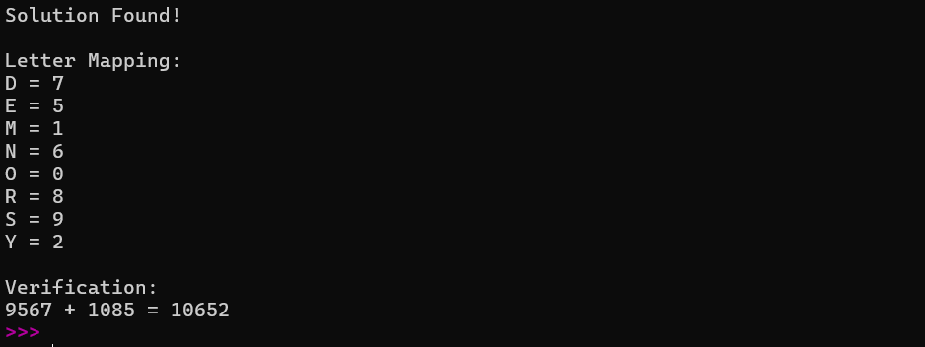

Result
The Python program was successfully implemented to solve the Crypt-Arithmetic Problem using Permutation Search (Backtracking approach). The program accepts the two operand words and the result word from the user, assigns unique digits to each letter, verifies the arithmetic equation, and displays the correct letter-to-digit mapping when a valid solution is found. This demonstrates the application of constraint satisfaction techniques in Artificial Intelligence.

5. Write the python program for Missionaries Cannibal problem

Aim
To develop a Python program to solve the Missionaries and Cannibals Problem using the Breadth-First Search (BFS) Algorithm by finding a safe sequence of moves to transfer all missionaries and cannibals across the river.

Algorithm
- Start the program.
- Initialize the starting state as (3 Missionaries, 3 Cannibals, Boat on Left Bank).
- Define the goal state as (0 Missionaries, 0 Cannibals, Boat on Right Bank).
- Insert the initial state into a queue.
- Repeat until the queue becomes empty:
  - Remove the front state.
  - If the current state is the goal state, display the solution path and stop.
  - Generate all valid boat moves.
  - Check whether each generated state satisfies the safety conditions.
  - Add all valid and unvisited states to the queue.
- If no solution exists, display "No Solution Exists."
- Stop.

Program
from collections import deque
# Check whether a state is valid
def is_valid(state):
M_left, C_left, boat = state
M_right = 3 - M_left
C_right = 3 - C_left
# Check limits
if M_left < 0 or M_left > 3 or C_left < 0 or C_left > 3:
return False
# Missionaries should not be outnumbered on left bank
if M_left > 0 and C_left > M_left:
return False
# Missionaries should not be outnumbered on right bank
if M_right > 0 and C_right > M_right:
return False
return True
# Generate possible next states
def get_next_states(state):
M_left, C_left, boat = state
moves = [
(1, 0), # 1 Missionary
(2, 0), # 2 Missionaries
(0, 1), # 1 Cannibal
(0, 2), # 2 Cannibals
(1, 1) # 1 Missionary and 1 Cannibal
]
next_states = []
for m, c in moves:
if boat == 0: # Boat on left side
new_state = (M_left - m, C_left - c, 1)
else: # Boat on right side
new_state = (M_left + m, C_left + c, 0)
if is_valid(new_state):
next_states.append(new_state)
return next_states
# BFS Algorithm
def bfs():
start = (3, 3, 0) # (Missionaries Left, Cannibals Left, Boat)
goal = (0, 0, 1)
queue = deque([(start, [])])
visited = set()
while queue:
state, path = queue.popleft()
if state in visited:
continue
visited.add(state)
path = path + [state]
if state == goal:
return path
for next_state in get_next_states(state):
if next_state not in visited:
queue.append((next_state, path))
return None

# Main Program
solution = bfs()
if solution:
print("Solution Found:\n")
print("State Format: (Missionaries Left, Cannibals Left, Boat)")
print("Boat: 0 = Left Bank, 1 = Right Bank\n")
for step in solution:
print(step)
else:
print("No Solution Exists.")

Input
No user input required.
(The problem starts with 3 Missionaries, 3 Cannibals, and the boat on the left bank.)

Output
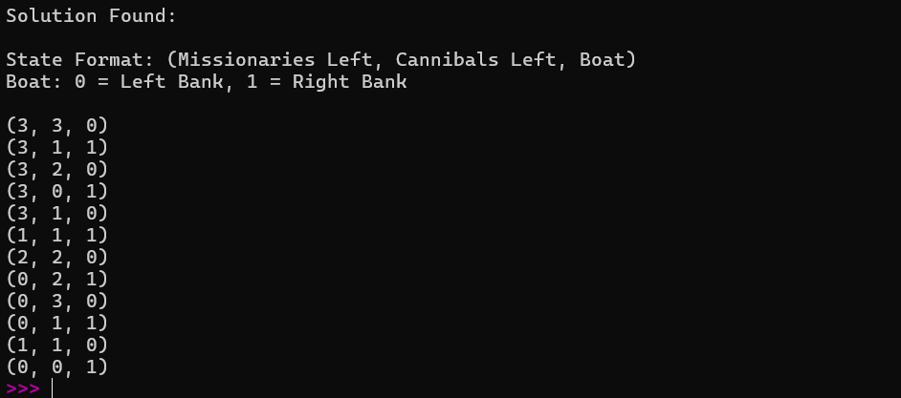

Result
The Python program was successfully implemented to solve the Missionaries and Cannibals Problem using the Breadth-First Search (BFS) Algorithm. The program finds the shortest valid sequence of moves that transfers all missionaries and cannibals safely from the left bank to the right bank without violating the safety constraints, and displays each intermediate state of the solution.

6. Write the python program for Vacuum Cleaner problem
Aim
To develop a Python program to simulate the Vacuum Cleaner Problem in Artificial Intelligence by cleaning all dirty rooms using a simple reflex agent.

Algorithm
- Start the program.
- Read the status of Room A and Room B from the user (Dirty/Clean).
- Read the initial location of the vacuum cleaner.
- If the current room is dirty, clean it.
- Move to the other room.
- If the other room is dirty, clean it.
- Display the action performed in each room.
- Display the final status of both rooms.
- Stop.

Program
# Vacuum Cleaner Problem

# Input room status
roomA = input("Enter status of Room A (Dirty/Clean): ").capitalize()
roomB = input("Enter status of Room B (Dirty/Clean): ").capitalize()

# Input vacuum location
location = input("Enter Vacuum Location (A/B): ").upper()

print("\nInitial State:")
print("Room A:", roomA)
print("Room B:", roomB)
print("Vacuum Location:", location)

# Cleaning process
if location == "A":
if roomA == "Dirty":
print("\nCleaning Room A...")
roomA = "Clean"

print("Moving to Room B...")

if roomB == "Dirty":
print("Cleaning Room B...")
roomB = "Clean"

elif location == "B":
if roomB == "Dirty":
print("\nCleaning Room B...")
roomB = "Clean"

print("Moving to Room A...")

if roomA == "Dirty":
print("Cleaning Room A...")
roomA = "Clean"

else:
print("Invalid Vacuum Location!")

print("\nFinal State:")
print("Room A:", roomA)
print("Room B:", roomB)
print("\nAll rooms are clean.")

Input
Enter status of Room A (Dirty/Clean): Dirty
Enter status of Room B (Dirty/Clean): Clean
Enter Vacuum Location (A/B): A

Output
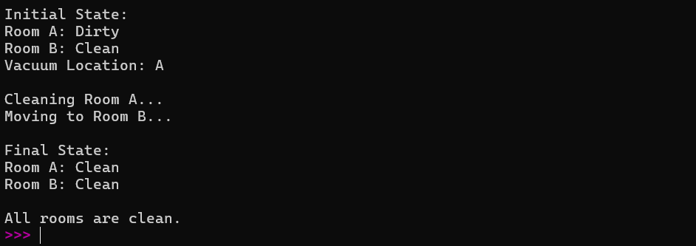

Result
The Python program was successfully implemented to simulate the Vacuum Cleaner Problem. The program accepts the initial status of Room A and Room B along with the vacuum cleaner's initial location, cleans all dirty rooms, and displays the sequence of actions and the final state where both rooms are clean.

7.Write the python program to implement BFS.

Aim
To develop a Python program to implement the Breadth-First Search (BFS) algorithm for traversing a graph starting from a user-specified source node.

Algorithm
- Start the program.
- Read the number of vertices and edges from the user.
- Create an adjacency list to represent the graph.
- Read all the edges and store them in the adjacency list.
- Read the starting vertex.
- Initialize an empty queue and a visited set.
- Insert the starting vertex into the queue and mark it as visited.
- Repeat until the queue becomes empty:
  - Remove the front vertex from the queue.
  - Display the current vertex.
  - Visit all adjacent unvisited vertices.
  - Mark them as visited and insert them into the queue.
- Stop.

Program
from collections import deque

# Read number of vertices and edges
n = int(input("Enter the number of vertices: "))
e = int(input("Enter the number of edges: "))

# Create adjacency list
graph = {}

for i in range(n):
vertex = input(f"Enter vertex {i+1}: ")
graph[vertex] = []

# Read edges
print("\nEnter the edges:")
for i in range(e):
u, v = input().split()
graph[u].append(v)
graph[v].append(u) # Remove this line for directed graph

# Read starting vertex
start = input("\nEnter the starting vertex: ")

# BFS Traversal
visited = set()
queue = deque()

visited.add(start)
queue.append(start)

print("\nBFS Traversal:")

while queue:
vertex = queue.popleft()
print(vertex, end=" ")

for neighbor in graph[vertex]:
if neighbor not in visited:
visited.add(neighbor)
queue.append(neighbor)

Input
Enter the number of vertices: 5
Enter the number of edges: 5

Enter vertex 1: A
Enter vertex 2: B
Enter vertex 3: C
Enter vertex 4: D
Enter vertex 5: E

Enter the edges:
A B
A C
B D
C E
D E

Enter the starting vertex: A

Output

Result
The Python program was successfully implemented to perform Breadth-First Search (BFS) on a graph. The program accepts the graph and starting vertex from the user, traverses the graph level by level using a queue, and displays the BFS traversal order.

8.Write the python program to implement DFS.

Aim
To develop a Python program to implement the Depth-First Search (DFS) algorithm for traversing a graph starting from a user-specified source node.

Algorithm
- Start the program.
- Read the number of vertices and edges from the user.
- Create an adjacency list to represent the graph.
- Read all the edges and store them in the adjacency list.
- Read the starting vertex.
- Initialize an empty visited set.
- Visit the starting vertex and mark it as visited.
- Display the current vertex.
- Recursively visit each unvisited adjacent vertex.
- Continue until all reachable vertices are visited.
- Stop.

Program
# Function to perform DFS
def dfs(graph, vertex, visited):
visited.add(vertex)
print(vertex, end=" ")

for neighbor in graph[vertex]:
if neighbor not in visited:
dfs(graph, neighbor, visited)

# Main Program
n = int(input("Enter the number of vertices: "))
e = int(input("Enter the number of edges: "))

# Create adjacency list
graph = {}

for i in range(n):
vertex = input(f"Enter vertex {i+1}: ")
graph[vertex] = []

# Read edges
print("\nEnter the edges:")
for i in range(e):
u, v = input().split()
graph[u].append(v)
graph[v].append(u) # Remove this line for directed graph

# Read starting vertex
start = input("\nEnter the starting vertex: ")

visited = set()

print("\nDFS Traversal:")
dfs(graph, start, visited)

Input
Enter the number of vertices: 5
Enter the number of edges: 5

Enter vertex 1: A
Enter vertex 2: B
Enter vertex 3: C
Enter vertex 4: D
Enter vertex 5: E

Enter the edges:
A B
A C
B D
C E
D E

Enter the starting vertex: A

Output
Note: The DFS traversal order may vary depending on the order in which the edges are entered.

Result
The Python program was successfully implemented to perform Depth-First Search (DFS) on a graph. The program accepts the graph and the starting vertex from the user, traverses the graph using the recursive Depth-First Search algorithm, and displays the DFS traversal order.

9.Write the python to implement Travelling Salesman Problem

Aim
To develop a Python program to solve the Travelling Salesman Problem (TSP) by finding the minimum cost path that visits each city exactly once and returns to the starting city.

Algorithm
- Start the program.
- Read the number of cities from the user.
- Read the cost matrix representing the distances between the cities.
- Generate all possible routes starting from the first city.
- Calculate the total travel cost for each route.
- Compare the costs of all possible routes.
- Select the route with the minimum total cost.
- Display the optimal route and its minimum travel cost.
- Stop.

Program
from itertools import permutations

# Read number of cities
n = int(input("Enter the number of cities: "))

print("Enter the Cost Matrix:")

cost = []
for i in range(n):
row = list(map(int, input().split()))
cost.append(row)

cities = list(range(n))
start = 0

min_cost = float('inf')
best_path = None

# Generate all possible tours
for path in permutations(cities[1:]):
current_path = (start,) + path
current_cost = 0

# Calculate path cost
for i in range(len(current_path) - 1):
current_cost += cost[current_path[i]][current_path[i + 1]]

# Return to starting city
current_cost += cost[current_path[-1]][start]

if current_cost < min_cost:
min_cost = current_cost
best_path = current_path

# Display result
print("\nOptimal Path:")
for city in best_path:
print(city, end=" -> ")
print(start)

print("Minimum Cost =", min_cost)

Input
Enter the number of cities: 4

Enter the Cost Matrix:
0 10 15 20
10 0 35 25
15 35 0 30
20 25 30 0

Output
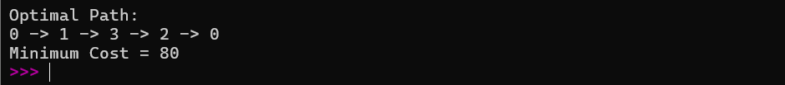
Note: If there are multiple optimal routes with the same minimum cost, the program may display any one of them.

Result
The Python program was successfully implemented to solve the Travelling Salesman Problem (TSP). The program accepts the number of cities and the cost matrix from the user, evaluates all possible tours using permutation search, identifies the route with the minimum travel cost, and displays the optimal path along with its minimum cost.

10.Write the python program to implement A* algorithm

Aim
To develop a Python program to implement the A* Search Algorithm for finding the shortest path between two nodes in a graph using heuristic values.

Algorithm
- Start the program.
- Read the graph, heuristic values, start node, and goal node from the user.
- Initialize the Open List with the start node and an empty Closed List.
- Assign the cost values:
  - g(n) = Cost from the start node.
  - h(n) = Heuristic value.
  - f(n) = g(n) + h(n).
- Repeat until the Open List becomes empty:
  - Select the node with the minimum f(n) value.
  - If the selected node is the goal node, display the shortest path and stop.
  - Move the selected node to the Closed List.
  - Generate all neighboring nodes.
  - Compute g(n), h(n), and f(n) for each neighbor.
  - Update the Open List if a better path is found.
- If no path exists, display "Path not found."
- Stop.

Program
import heapq

# Read graph
graph = {}
n = int(input("Enter the number of nodes: "))

print("\nEnter node details:")

for _ in range(n):
node = input("Node: ")
m = int(input(f"Enter number of neighbors of {node}: "))
graph[node] = []

for i in range(m):
neighbor = input("Neighbor: ")
cost = int(input("Cost: "))
graph[node].append((neighbor, cost))

# Read heuristic values
heuristic = {}

print("\nEnter Heuristic Values:")
for node in graph:
heuristic[node] = int(input(f"h({node}) = "))

# Read start and goal
start = input("\nEnter Start Node: ")
goal = input("Enter Goal Node: ")

# A* Algorithm
pq = []
heapq.heappush(pq, (heuristic[start], 0, start, [start]))

visited = {}

while pq:
f, g, current, path = heapq.heappop(pq)

if current == goal:
print("\nShortest Path:", " -> ".join(path))
print("Total Cost:", g)
break

if current in visited and visited[current] <= g:
continue

visited[current] = g

for neighbor, cost in graph[current]:
new_g = g + cost
new_f = new_g + heuristic[neighbor]

heapq.heappush(
pq,
(new_f, new_g, neighbor, path + [neighbor])
)
else:
print("Path not found.")

Input
Enter the number of nodes: 4

Enter node details:

Node: A
Enter number of neighbors of A: 2
Neighbor: B
Cost: 1
Neighbor: C
Cost: 4

Node: B
Enter number of neighbors of B: 2
Neighbor: C
Cost: 2
Neighbor: D
Cost: 5

Node: C
Enter number of neighbors of C: 1
Neighbor: D
Cost: 1

Node: D
Enter number of neighbors of D: 0

Enter Heuristic Values:
h(A) = 7
h(B) = 6
h(C) = 2
h(D) = 0

Enter Start Node: A
Enter Goal Node: D

Output

Result
The Python program was successfully implemented to perform the A* Search Algorithm. The program accepts the graph, heuristic values, start node, and goal node from the user, computes the shortest path using the evaluation function f(n) = g(n) + h(n), and displays the optimal path along with the minimum total cost.

Write the python program for Map Coloring to implement CSP

Aim
To develop a Python program to solve the Map Coloring Problem using the Constraint Satisfaction Problem (CSP) approach by assigning colors to regions such that no two adjacent regions have the same color.

Algorithm
- Start the program.
- Read the number of regions from the user.
- Read the names of the regions.
- Read the adjacency information for each region.
- Read the available colors.
- Assign colors to regions one by one using the Backtracking Algorithm.
- For each region:
  - Check whether assigning a color violates the coloring constraint.
  - If safe, assign the color and move to the next region.
  - Otherwise, try another color.
  - If no color is suitable, backtrack.
- Repeat until all regions are assigned valid colors.
- Display the color assigned to each region.
- Stop.

Program
# Check if assigning a color is safe
def is_safe(region, color, assignment, graph):
for neighbor in graph[region]:
if neighbor in assignment and assignment[neighbor] == color:
return False
return True

# Backtracking function
def map_coloring(graph, colors, assignment, regions, index):
if index == len(regions):
return True

region = regions[index]

for color in colors:
if is_safe(region, color, assignment, graph):
assignment[region] = color

if map_coloring(graph, colors, assignment, regions, index + 1):
return True

del assignment[region]

return False

# Main Program
n = int(input("Enter number of regions: "))

regions = []
graph = {}

print("\nEnter region names:")
for i in range(n):
region = input()
regions.append(region)
graph[region] = []

print("\nEnter adjacent regions:")

for region in regions:
neighbors = input(f"Neighbors of {region} (space-separated): ").split()
graph[region] = neighbors

colors = input("\nEnter available colors (space-separated): ").split()

assignment = {}

if map_coloring(graph, colors, assignment, regions, 0):
print("\nMap Coloring Solution:")
for region in regions:
print(region, "->", assignment[region])
else:
print("\nNo Solution Exists.")

Input
Enter number of regions: 4

Enter region names:
A
B
C
D

Enter adjacent regions:
Neighbors of A (space-separated): B C
Neighbors of B (space-separated): A C D
Neighbors of C (space-separated): A B D
Neighbors of D (space-separated): B C

Enter available colors (space-separated):
Red Green Blue

Output
Map Coloring Solution:

A -> Red
B -> Green
C -> Blue
D -> Red
Note: The color assignment may vary depending on the order of regions and colors entered, but the solution will always satisfy the constraint that no two adjacent regions have the same color.

Result
The Python program was successfully implemented to solve the Map Coloring Problem using the Constraint Satisfaction Problem (CSP) approach. The program accepts the regions, adjacency information, and available colors from the user, assigns colors using the Backtracking Algorithm, and displays a valid color assignment such that no two adjacent regions share the same color.

